- 在浏览器地址栏中输入www.icourse163.org
Enter www.icourse163.org in the browser address bar.
- 登录中国大学慕课网站，如果没有账号，请先注册新账号。
Log in to the MOOC website of China University. If you don't have an account, please register a new account first.
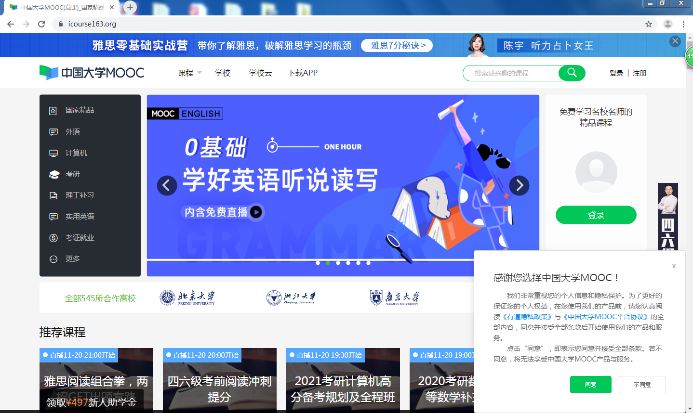

- 输入用户名和密码登录网站。
Enter the user name and password to log in to the website.
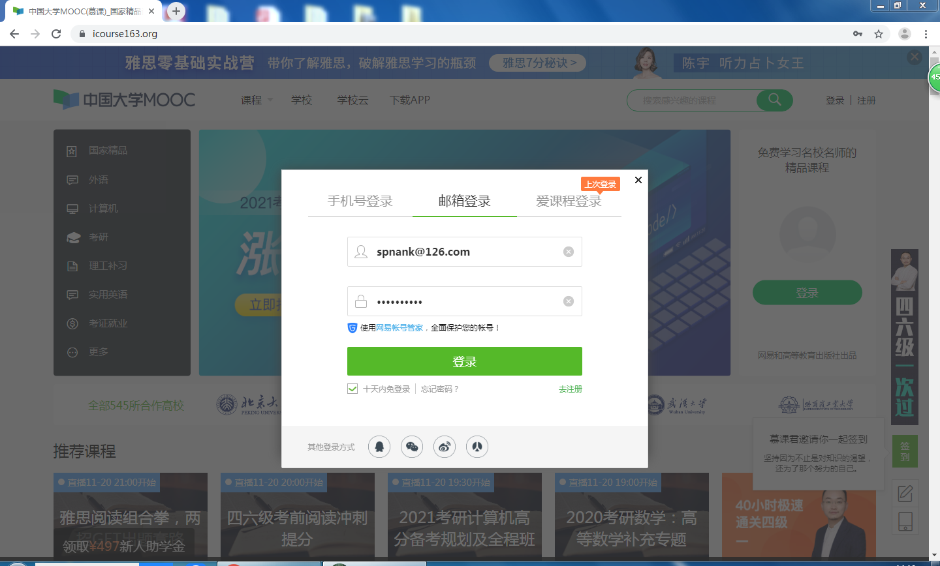
- 登录网站后，请在搜索框中输入 “走进中国”
After logging into the website, please enter "走进中国" in the search box
- 点击走进中国课程链接。
Click the "走进中国" course link.

- 点击立即参加按钮，报名参加学习。
Click the "立即参加（join now）" button to sign up for the study.
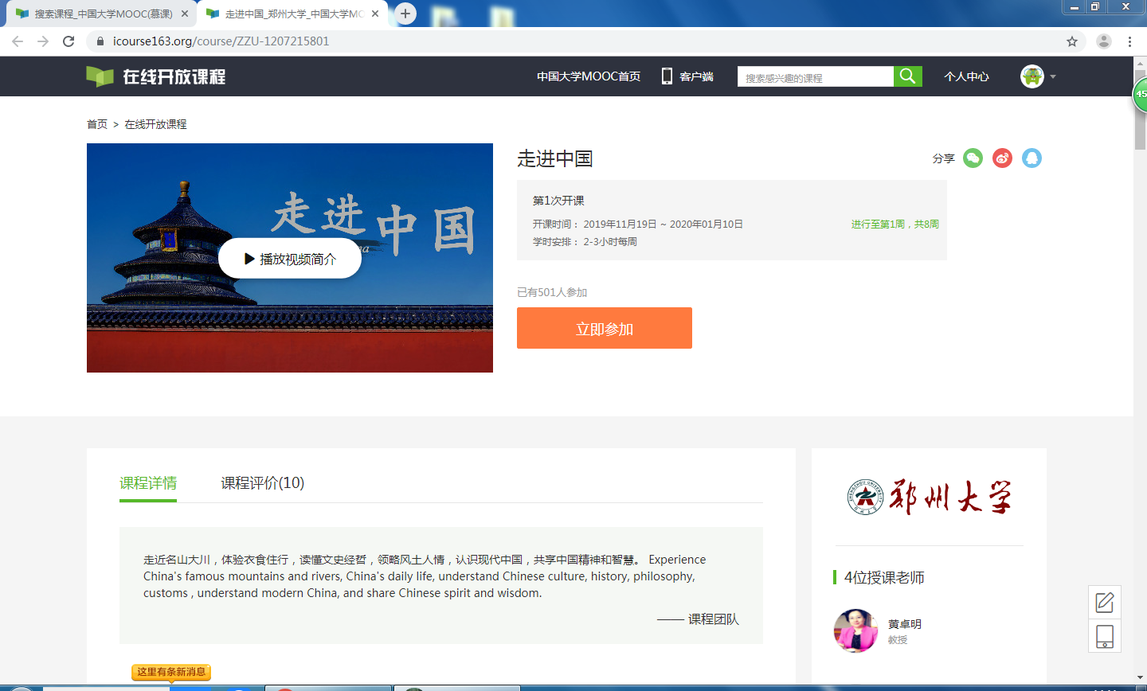
- 报名成功后，你就已经注册为课程的学员了。
The website shows that the registration is successful, then you have already registered as a student of the course.
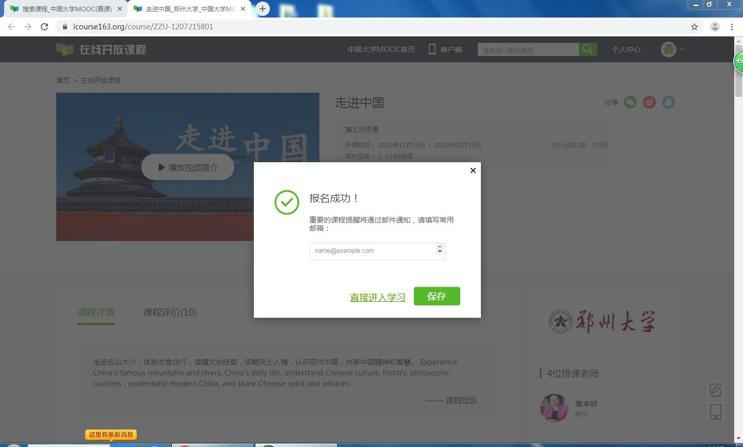

8.接下来，点击开始学习，享受走进中国之旅吧！
Next, click”“开始学习”（start）to learn and enjoy the journey to China!
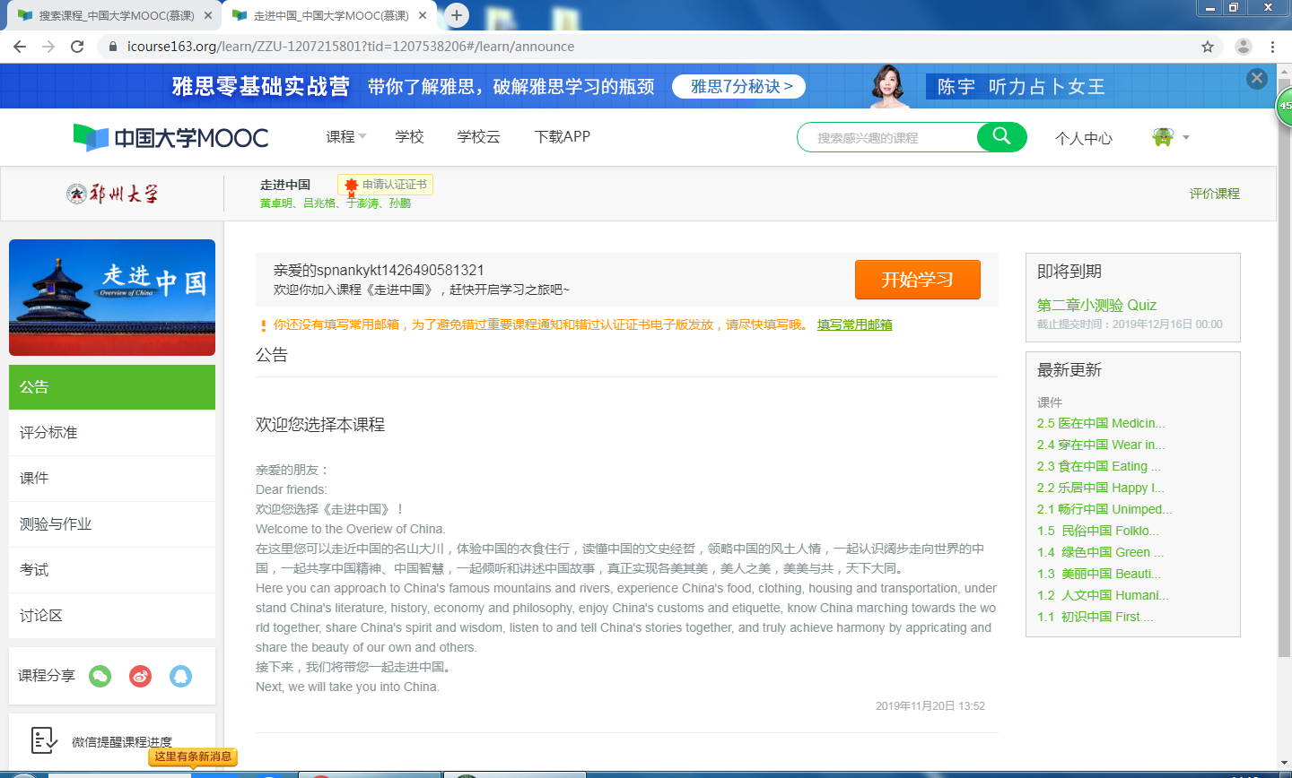

9.请按照章节顺序观看视频。
Please watch the video in the order of the chapters.
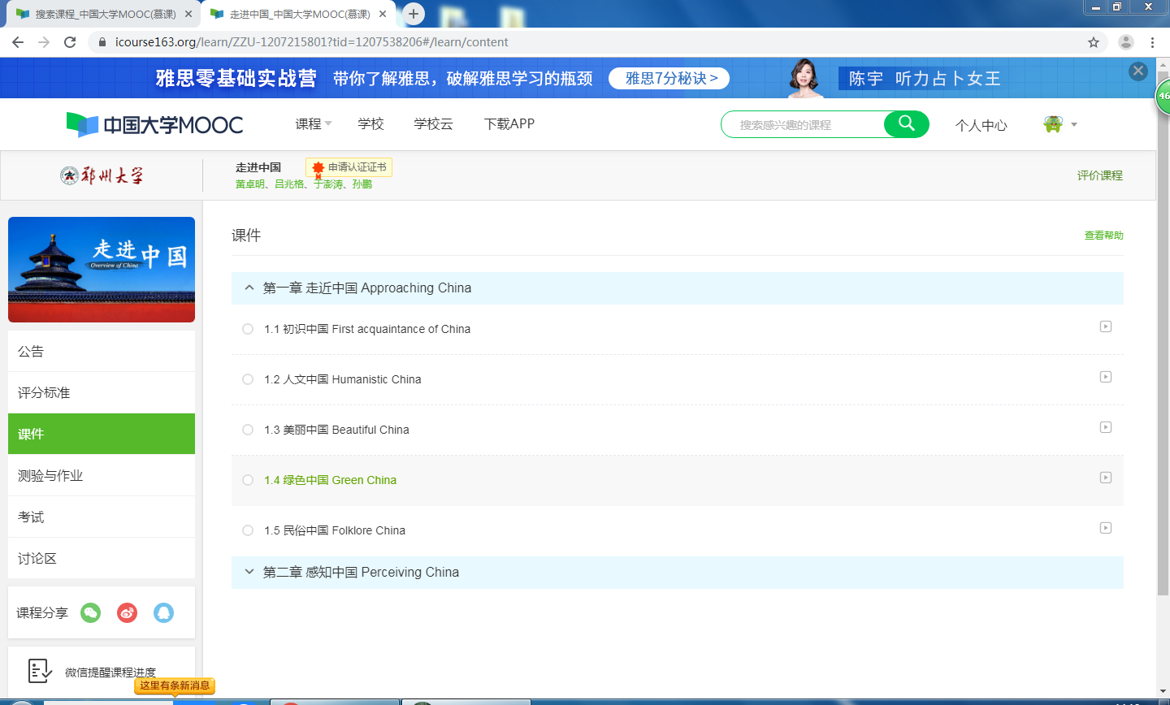
10.点击章节目录链接后，就可以观看视频了。
Click on the chapter directory link to watch the video.
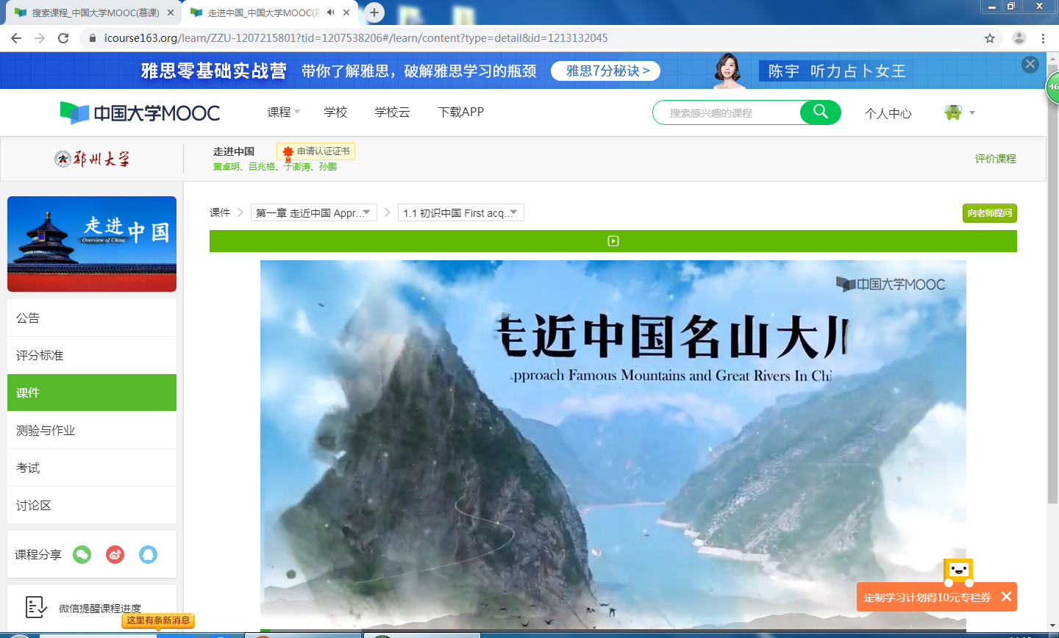

- 当然，您可以反复观看视频，以便完全掌握本节视频所讲授的内容。
Of course, you can watch the video over and over again, so that you can fully grasp the content of this video.
